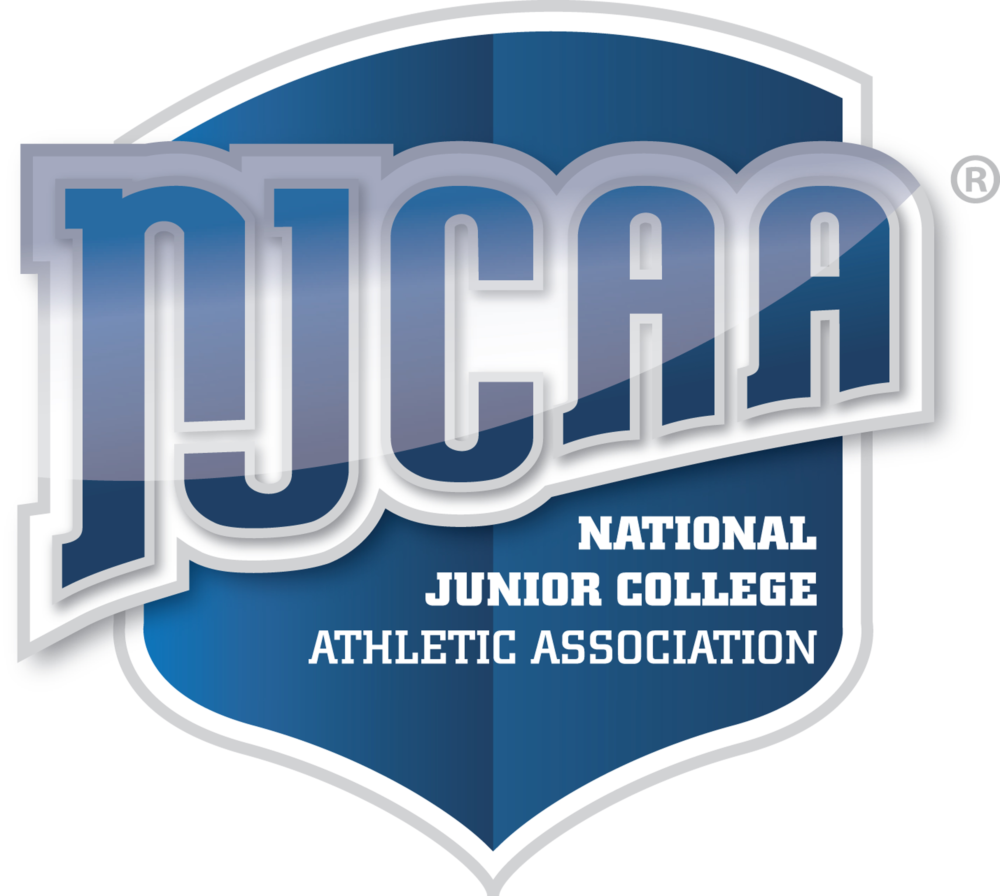

Information for a Prospective NJCAA Student-Athlete

The National Junior College Athletic Association (NJCAA) is committed to providing quality athletic opportunities to enhance the entire collegiate learning experience or its students. The Association and its member colleges strive to provide equal opportunities for all concerned student-athletes. The Association is sensitive to the special needs and circumstances of the Community/Junior College student while keeping within the high academic standards of our 525 member institutions.

GENERAL INFORMATION

Q: What sports are sponsored by the NJCAA?
A: The NJCAA provides opportunities for participation, including National Championships, for student-athletes in the following sports:

Fall Baseball, Spring Baseball, Basketball, Bowling, Cross Country, Football, Fall Golf, Spring Golf, Half Marathon, Ice Hockey, Indoor Track and Field, Spring Lacrosse, Fall Lacrosse, Outdoor Track and Field, Fall Softball, Spring Softball, Fall Soccer, Spring Soccer, Swimming & Diving, Fall Tennis, Spring Tennis, Fall Volleyball, Spring Volleyball and Wrestling.

Q: Whose rules do I abide by?
A: Students participating on an intercollegiate level in any one of the certified sports of the NJCAA shall conform to the requirements of the Rules of Eligibility, the rules and regulations of the conference with which the college is affiliated, and also the rules of the college at which the students are attending and participating.

Q: How do I determine my initial eligibility?
A: Due to the unique academic and athletic situation of each individual, and the complexity of the NJCAA eligibility rules, it is recommended that each potential student-athlete discuss their athletic eligibility with the athletic personnel at the NJCAA college where they have chosen to attend. Should the athletic staff have any questions in determining an individual's eligibility, the college may contact the NJCAA National Office for assistance.

Q: Must I have graduated from high school?
A: Students must be a high school graduate or must have received a high school equivalency diploma or have been certified as having passed a national test such as the General Education Development Test (GED).

Q: What if I am taking classes at a college while still in high school?
A: If a student is enrolled in twelve or more credits at a college while still enrolled and completing their high school education, they are eligible for athletic participation if they complete a NJCAA High School Waiver Form (Form e.3) signed by their high school Principal and the College President. This option is not available to those students whose high school class has already graduated.

Q: How many seasons may I participate in a sport?
A: Students are allowed two (2) seasons of competition in any sport at a NJCAA college, if they have not participated at any intercollegiate level during two (2) seasons previously. Playing in one or more regularly scheduled contests prior to post-season competition uses one season of participation in that sport.

Warning: Students who falsify their academic records and /or information about previous athletic participation shall be barred from any further competition in any NJCAA member college at any time.

Q: Do I qualify as an amateur?
A: Amateur players are those who engage in sports for the physical, mental, or social benefits they derive in participation and to whom athletics is a vocation and not a source of personal monetary gains. Be sure of your amateur status by checking the NJCAA amateur rules (Article V, Section 11, NJCAA Handbook) or checking with a NJCAA athletic director.

Q: While playing a sport I want to enter an open tournament or play with another team. May I?
A: While the season of any sport is in progress, as determined by the published schedule of the college, students are not allowed to participate in that same sport for any other team except in the following sports: bowling, golf and tennis.

If a student wishes to enter any open competition as a representative of their college, the competition must be listed on the published schedule of the college and the student must meet all NJCAA eligibility requirements.

If a student is not representing a NJCAA college, they may enter open or "exhibition" competition without NJCAA approval. A college shall not, however, furnish the student with any assistance (equipment, transportation, lodging or meals) when participating in such events.

Q: What about All-Star competitions?
A: Student participation in athletic events such as All-Star games must be approved by the NJCAA National Office.
The NJCAA does NOT restrict the number of All-Star games in which a High School student may participate prior to attendance at a NJCAA college.

LETTER OF INTENT/SCHOLARSHIP AGREEMENT

Q: What is the NJCAA Letter of Intent?
A: The NJCAA Letter of Intent is used to commit an individual to a specific institution for a period of one year. The form is only valid for NJCAA member colleges and has no jurisdiction over NCAA or NAIA colleges.

Q: What if I sign a NJCAA and a NCAA Letter of Intent?
A: A student is allowed to sign a Letter of Intent with both a NJCAA and a NCAA college without sanction. The student may not, however, sign a NJCAA Letter of Intent with two NJCAA colleges. If a student does sign with two NJCAA colleges, that student will become immediately ineligible to compete in NJCAA competition for the next academic year in any sport.

Q: What kind of grant-in-aid can I receive from NJCAA institutions?
A: An athletic grant-in-aid may be awarded to any student-athlete in recognition of his/her athletic ability provided the student-athlete is admitted to the institution as a regular student. It shall be limited to a maximum of tuition, fees, room, board, books and course related material, and transportation costs one time per academic year to and from the college by direct route.

Q: If I am awarded an athletic scholarship and voluntarily do not participate, could I lose my scholarship?
A: Cancellation or modification of an athletic scholarship during the period of its effectiveness is allowed for the following reasons only:
- If the athlete becomes ineligible for participation in athletics because of academic and/or disciplinary reasons.
- For misconduct (unrelated to athletic ability) found by the person or body in charge of general discipline at the institution.
- If the student-athlete voluntarily withdraws from a sport prior to the institution's first competition in that sport.
- Graduation
Colleges may also include attachments to the NJCAA Letter of Intent which stipulates conditions for the cancellation of an athletic scholarship that are more stringent than those listed above.

Q: One NJCAA school can offer me a full scholarship, and one school can't offer me anything. Why?
A: Each institution belonging to the NJCAA can choose to compete on the Division I, II or III level in designated sports. Division I colleges may offer full athletic scholarships, Division II colleges are limited to awarding tuition, fees and books, and Division III institutions may provide no athletically related financial assistance. However, NJCAA colleges that do not offer athletic aid may choose to participate at the Division I or II level if they so desire.

ELIGIBILITY RULES

Q: Must I be a full-time student during the season?
A: Students must maintain full-time status during the season of the sport(s) in which they have chosen to participate (full-time status being 12 credit hours or more).

Q: What determines my eligibility after my initial full-time enrollment?
A: Eligibility is determined prior to the last official date to register for the term as published in the college catalog. At that time, the student must have:
- Prior to the fifteenth calendar day from the beginning date of the term for the second full-time semester, as published in the college catalog, a student-athlete must have passed 12 semester hours with a 1.75 GPA or higher.
- Prior to the fifteenth calendar day from the beginning date of the term for the third full-time semester, and all subsequent semesters thereafter, as published in the college catalog, a student-athlete must satisfy one of the following four requirements to be eligible for the upcoming term:
  - Pass a minimum of 12 semester hours with a 2.00 GPA or higher during the previous semester of full-time enrollment,
OR
  - Pass an accumulation of semester hours equal to 12 multiplied by the number of semesters in which the student-athlete was previously enrolled full-time with a GPA of 2.00 or higher,
OR
- A first season participant must have passed a minimum accumulation of 24 credit hours with a 2.00 GPA or higher for the initial term of participation, regardless of previous term or other accumulation requirements (NOTE: This only establishes eligibility for the initial term, not subsequent terms.),
OR
- A first or second season participant must have passed a minimum accumulation of 36 credit hours for a fall sport, 48 credit hours for a spring sport, with a 2.00 GPA or higher, regardless of previous term or other accumulation requirement.

Q: Are there additional requirements I must meet to participate?
A: A student must also make progress towards graduation. Before participation in a second season in any certified sport(s), a student must have:
- Obtained at least 24 semester hours or 36 quarter hours with a 2.00 GPA or higher and one of 2-3 below:
- Pass a minimum of 12 semester hours with a 2.00 GPA or higher during the previous semester of full-time enrollment,
OR
- Pass an accumulation of semester hours equal to 12 multiplied by the number of semesters in which the student-athlete was previously enrolled full-time with a GPA of 2.00 or higher,

- A first or second season participant must have passed a minimum accumulation of 36 credit hours for a fall sport, 48 credit hours for a spring sport, with a 2.00 GPA or higher, regardless of previous term or other accumulation requirement.

Q: I played one year on a club team, how many years of intercollegiate eligibility do I have left?
A: Participation on a designated collegiate club team in a NJCAA certified sport will constitute one (1) season of participation.

Q: I took a semester off to earn money for college, will I be immediately eligible to play once I enroll as a full-time student?
A: Students must be enrolled full-time (twelve or more credits) at the college where they have chosen to participate when the regular season schedule of a sport begins. Students not enrolled during the term when the season begins remain ineligible throughout the season schedule unless they enroll on the first possible enrollment date following:
- Their release from Active Armed Services of the United States with a discharge other than dishonorable.
- Their return from a religious mission.
- Their graduation from a high school or receipt of an equivalency diploma.
- Their transfer from an NJCAA member college which has dropped a sport after the school year begins.
Students that satisfy one of the four exceptions become eligible after the previous term has ended upon registration as a full time student for the new term. (Students must be added to the eligibility form before participating.)
- A student attending a multi-campus college may, if at the campus of his/her enrollment a sport is not offered, participate in that sport at any campus within the system that offers said sport.
Requirements for Multi-Campus designation
a. The various campuses involved have a common title.
b. The various campuses involved have a common CEO.
c. The various campuses involved are not individually accredited.
d. The various campuses do not duplicate any sports.
e. The various campuses involved must designate one individual per system as the contact.
Multi-campus designation must be approved by the NJCAA

Q: What if I start college and then withdraw?
A: The following withdrawal policy applies to students that are attending any college.
- Students are allowed fifteen (15) calendar days from the beginning date of classes to withdraw completely or to withdraw to less than twelve credits (part-time) and not have that term affect their future eligibility, provided they have not participated in any athletic competition. (Refer to Section 4.G.)
- Students that have participated and withdraw within the first fifteen (15) calendar days of a particular term are not eligible for athletic participation and must re- establish their eligibility in accordance with the provisions of section 4.D or 4.E. The term in which the student participates must be considered the same as a term of full-time attendance.

Q: May a part-time student participate?
A: Students who have never been full-time (12 or more credits) at any colleges may become eligible for competition in a sport by meeting the following conditions:

        - The student-athletes attend the same institution at least one academic year as part-time student prior to the year of his/her participation passing at least 12 credit hours with an overall grade point average of 1.75 or better during that year.
        - During each term of participation, the student-athletes must carry at least six credit hours in the same institution.
        - Prior to a second season of participation in any sport, the student-athletes must pass a total of 24 credit hours with a 2.00 GPA or higher.
        - If in any term the student-athletes enroll full-time, they forfeit the privileges under this provision of the part-time eligibility rule.
        - Student-athletes who withdraw completely or to less than six credit hours become immediately ineligible.
        - Institutions who apply for this provision of the rules, must submit a transcript to establish the eligibility of the student-athletes.

Q: Upon returning to college following an extended absence, must I meet the current eligibility requirements?
A: Students who have not been enrolled in college in twelve (12) or more credit hours (full-time) for a period of eighteen calendar months or longer shall be exempt from previous term and/or accumulation requirements as set forth in Article V, Section 4.d or 4.e (not Section 4.f) of the NJCAA bylaws. Students who have served eighteen calendar months in the Armed Forces of the United States, church mission or with a recognized foreign aid service shall be exempt form Section 4.d, 4.e and 4.f. Note, this is a one time exemption, available only for the first full-time term after the period of non-attendance.

Q: What are the requirements for transfer students?
A: All transfer students must adhere to the eligibility rules of the NJCAA to be eligible for participation at a member institution. Check Article V, Section 10 of the NJCAA Handbook to make sure you meet all transfer requirements of the NJCAA.

Q: What requirements will I have to meet to transfer from a two-year college to a four-year college?
A: Questions relative to a transfer from a NJCAA college to a four-year program must be addressed by the four-year college and/or their national governing body (ie. NCAA or NAIA).

Q: Are the rules uniform throughout the entire membership?
A: The various regions of the NJCAA may adopt rules which are more stringent than the national rules, but none that are less stringent. It would be best for you to check the rules that exist within the region in which you are interested in attending. Any member college can assist you with any regional differences, which may exist.

Q: I am a recent high school graduate and coaches have started to recruit me to play. What is allowed?
A: The following is permitted under NJCAA recruitment rules:

- No institution shall permit an athlete to be solicited to attend by the promise of a gift or inducement other than an athletic grant-in-aid.
- An institution may pay for one visit to its campus by direct route, for a stay not to exceed two days and two nights. The paid visit must be limited to the campus and local community where the college is located. A student-athlete must have completed his/her junior year in high school in order to receive an official recruiting visit by a member NJCAA college.
- While recruiting a potential athlete on campus, a college representative may purchase meals for the athlete. The value of the meals may not exceed the amount provided to a college employee while traveling on college business.
- A college official must authorize all funds utilized for recruitment purposes.

For further clarification of the recruiting rules, see Article VIII, Section 2. If a student-athlete signs a NJCAA Letter of Intent, all NJCAA institutions are obligated to respect that signing and shall cease to recruit that student-athlete. The student-athlete is obligated to notify any recruiter who contacts him/her of the signing.

For more information about the National Junior College Athletic Association, write to: NJCAA, 1631 Mesa Avenue, Suite B, Colorado Springs, CO 80906 or contact your local NJCAA member college. Additional information can also be found on the NJCAA web site: www.njcaa.org

